Product images and details

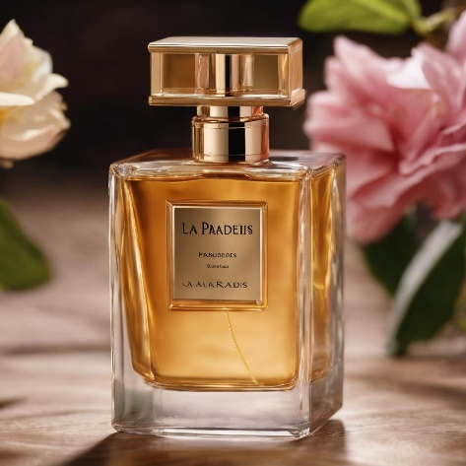

“La Belle Rose Étoilée" (The Beautiful Starry Rose): A floral fragrance with a hint of sweetness, similar to Lancôme La Vie Est Belle.

Woman

summer

Yellow

29.99£

250ml

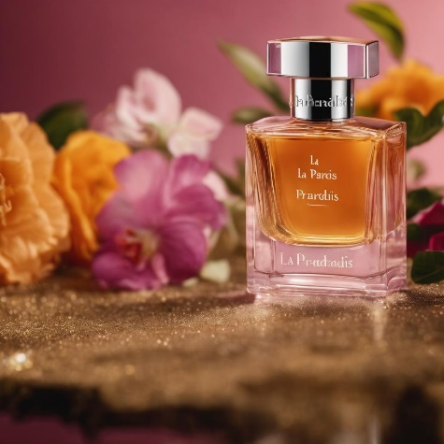

L'Amour Infini" (Infinite Love): A romantic scent with fruity and floral notes, evoking the allure of Chanel Coco Mademoiselle.

Woman

Winter

Brown

29.99£

150ml

"La Douce Séduction" (The Sweet Seduction): A warm and sensual fragrance with vanilla and musk, akin to Yves Saint Laurent Black Opium.

Woman

Winter

Pink

19.99£

150ml

"La Fleur Mystique" (The Mystical Flower): A captivating blend of exotic blooms and spices, reminiscent of Gucci Bloom.

Woman

Summer

Pink

25.00£

150ml

L'Étoile Brillante" (The Shining Star): A sparkling and vibrant fragrance with a touch of citrus, similar to Dolce & Gabbana Light Blue.

Woman

Summer

Gold

39.99£

200ml

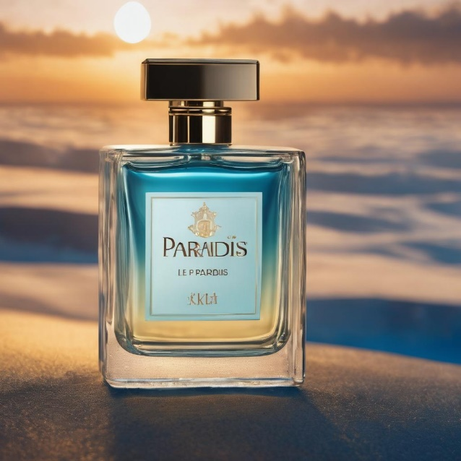

"L'Explorateur Aventureux" (The Adventurous Explorer): A fresh and invigorating scent with citrus and aquatic elements, A scent for daily occasions

Men

Summer

Blue

19.99£

200ml

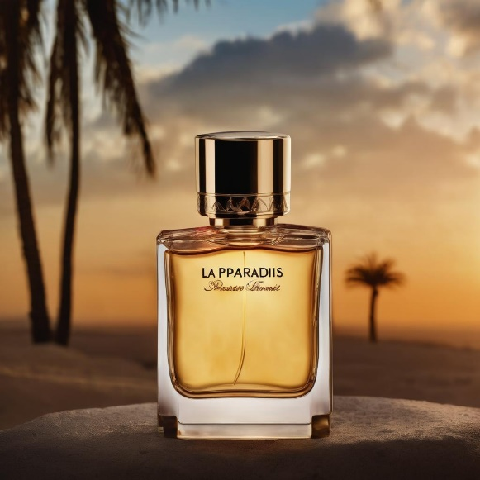

"Le Noble Gentilhomme" (The Noble Gentleman): A sophisticated and classic cologne with herbal and aromatic undertones, akin to Creed Aventus.

Men

Winter

Yellow

39.99£

200ml

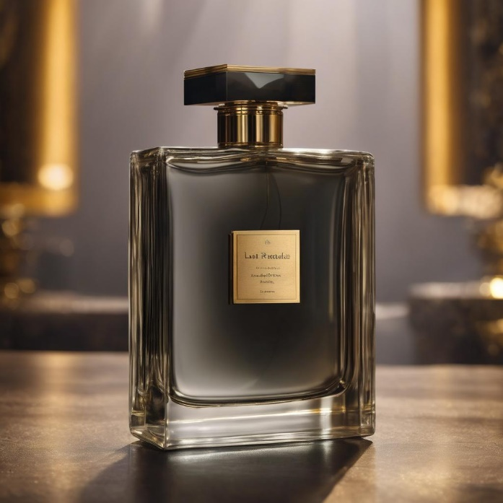

"Le Magnifique Cuir" (The Magnificent Leather): A rich and leathery aroma, evoking the essence of Tom Ford Tuscan Leather.

Men

Black

Winter

29.99£

250ml

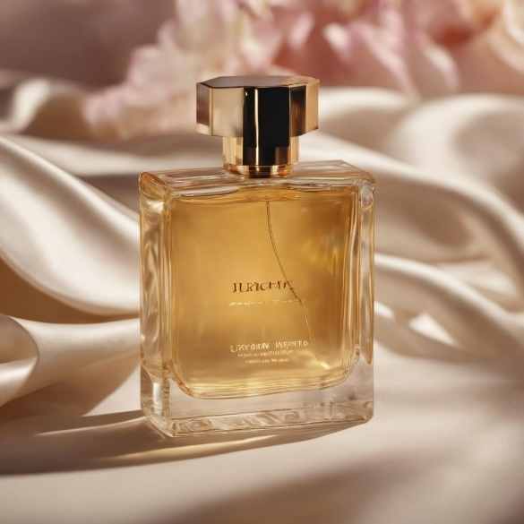

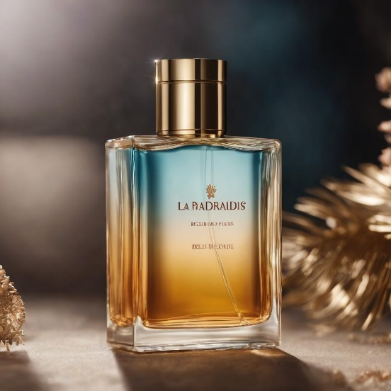

"L'Élégant Mystère" (The Elegant Mystery): A masculine fragrance with woody and spicy notes, reminiscent of Dior Sauvage

Men

Blue and yellow

Summer

20.00£

100ml

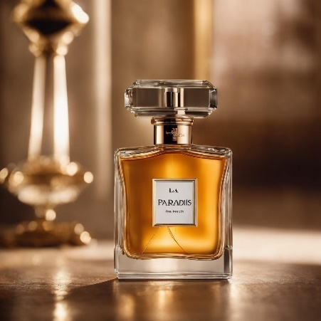

"L'Énigmatique Bois" (The Enigmatic Wood): An enigmatic blend of dark woods and oriental spices, reminiscent of Terre d'Hermès.

Men

brown

Winter

19.99£

100ml

" L'Essence Mystique " (The Mystical Essence): A captivating and enigmatic aroma that transcends gender, reminiscent of Tom Ford Black Orchid.

 Uni sex

Winter

Brown

49.99£

250ml

"Le Parfum Infini" (The Infinite Perfume): A timeless and unisex fragrance that embodies the essence of "Le Paradis."

Unisex

Gold

Winter

49.00£

150ml